**Greenwood College**

**Semester Two Examination, 2018**

**Question/Answer Booklet**

**MATHEMATICS APPLICATIONS**

**UNITS 1 AND 2**

**Section Two:**

**Calculator-assumed**

Your name

**Time allowed for this section**

Reading time before commencing work: ten minutes

Working time for this section: one hundred minutes

**Materials required/recommended for this section**

***To be provided by the supervisor***

This Question/Answer Booklet

Formula Sheet (retained from Section One)

***To be provided by the candidate***

Standard items: pens (blue/black preferred), pencils (including coloured), sharpener,

correction fluid/tape, eraser, ruler, highlighters

Special items: drawing instruments, templates, notes on two unfolded sheets of A4 paper, and up to three calculators approved for use in the WACE examinations

**Important note to candidates**

No other items may be taken into the examination room. It is **your** responsibility to ensure that you do not have any unauthorised notes or other items of a non-personal nature in the examination room. If you have any unauthorised material with you, hand it to the supervisor **before** reading any further.

## Structure of this paper

|  |  |  |  |  |  |
| --- | --- | --- | --- | --- | --- |
| Section | Number of questions available | Number of questions to be answered | Working  time (minutes) | Marks available | Percentage of examination |
| Section One:  Calculator-free | 8 | 8 | 50 | 52 | 35 |
| Section Two:  Calculator-assumed | 13 | 13 | 100 | 98 | 65 |
|  | | |  | **Total** | 100 |

|  |  |  |
| --- | --- | --- |
| Markers use only | | |
| Question | Maximum | Mark |
| 9 | 5 |  |
| 10 | 5 |  |
| 11 | 7 |  |
| 12 | 8 |  |
| 13 | 7 |  |
| 14 | 8 |  |
| 15 | 8 |  |
| 16 | 11 |  |
| 17 | 8 |  |
| 18 | 9 |  |
| 19 | 7 |  |
| 20 | 7 |  |
| 21 | 8 |  |
| S2 Total | 98 |  |
| S2 Wt (×0.6633) | 65% |  |

## Instructions to candidates

1. The rules for the conduct of examinations are detailed in the school handbook. Sitting this examination implies that you agree to abide by these rules.

2. Write your answers in this Question/Answer booklet.

3. You must be careful to confine your response to the specific question asked and to follow any instructions that are specified to a particular question.

4. Supplementary pages for the use of planning/continuing your answer to a question  
have been provided at the end of this Question/Answer booklet. If you use these pages to continue an answer, indicate at the original answer where the answer is continued, i.e. give the page number.

5. Show all your working clearly. Your working should be in sufficient detail to allow your answers to be checked readily and for marks to be awarded for reasoning. Incorrect answers given without supporting reasoning cannot be allocated any marks. For any question or part question worth more than two marks, valid working or justification is required to receive full marks. If you repeat any question, ensure that you cancel the answer you do not wish to have marked.

6. It is recommended that you do not use pencil, except in diagrams.

7. The Formula sheet is not to be handed in with your Question/Answer booklet.

Section Two: Calculator-assumed 65% (98 Marks)

This section has**thirteen (****13)** questions. Answer **all** questions. Write your answers in the spaces provided.

Working time: 100 minutes.

Question 9 (5 marks)

The following matrix $S$ shows the number of small sheds (in row $1$) and large sheds (in row $2$) sold by a company in each of three consecutive months. For example, the element $S_{13}$ represents the number of small sheds sold during the third month.

$$S=\left[\begin{matrix}72 & 68 & 75 \\ 51 & 59 & 38\end{matrix}\right]$$

(a) How many large sheds were sold in the second month? (1 mark)

(b) Calculate matrix $A$, where $A=S×\left[\begin{matrix}1 \\ 1 \\ 1\end{matrix}\right]$. (1 mark)

(c) Explain what information matrix $A$ shows. (1 mark)

Matrix $P=[\begin{matrix}141 & 236\end{matrix}]$, where $P_{11}$ and $P_{12}$ represent the profit, in dollars, made by selling a small shed and a large shed respectively.

(d) Using matrices $A$ and $P$, write down a calculation that will result in a matrix showing the total profit from selling all the sheds over the three-month period and state this profit.

(2 marks)

Question 10 (5 marks)

(a) Show use of trigonometry to determine the length of side $BC$ in the triangle below, where $∠BAC=115°, AB=61 \text{cm}$ and $AC=67 \text{cm}$. (2 marks)

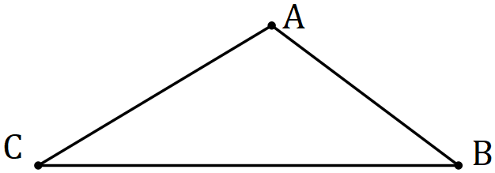

(b) Show use of trigonometry to determine the size of angle $∠PQR$ in the triangle below, where $∠QPR=96°, PQ=44 \text{cm}$ and $QR=85 \text{cm}$. (3 marks)

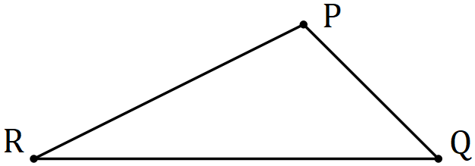

Question 11 (7 marks)

Soup is sold in cylindrical tins that have a diameter of $8.2 \text{cm}$ and a height of $14.2 \text{cm}$.

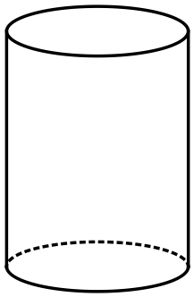

(a) Calculate the volume of the can. (3 marks)

(b) Calculate the capacity of the can in millilitres. ($1 \text{mL}=1 {\text{cm}}^{3}$) (2 marks)

(c) Before the cans are sealed, they are stood on their circular end and filled with $660 \text{mL}$ of soup. Determine the height of the soup in the can. (2 marks)

Question 12 (8 marks)

A hydroponic grower was trialling two different greenhouse systems for growing tomatoes. To compare the systems, the weight of tomatoes produced by each plant in the two greenhouses were recorded. The data is summarised below.

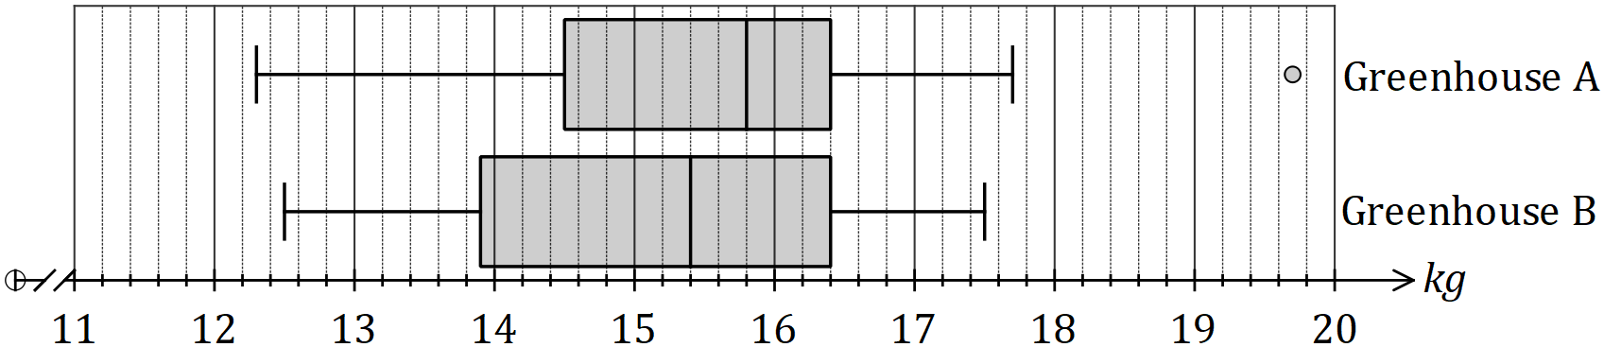

(a) Ignoring the outlier, compare the range of weights produced by plants in greenhouse $A$ with that of greenhouse $B$. (2 marks)

(b) State and use the interquartile ranges to compare the spread of weights produced by plants in greenhouse $A$ with that of greenhouse $B$. (2 marks)

(c) Using the result of a relevant calculation, explain why one of the weights in greenhouse $A$ was identified as an outlier. (2 marks)

(d) Explain whether there is evidence to support the conjecture that the system in one greenhouse produces a larger crop of tomatoes than the other. (2 marks)

Question 13 (7 marks)

Individual use coffee bags are packed in boxes of $11$, $21$ or $31$. Customers can buy cartons containing $4$, $5$ or $8$ boxes, as shown in the following table.

|  |  |  |  |
| --- | --- | --- | --- |
| **Carton** | **Carton price ($)** | **Boxes per carton** | **Coffee bags per box** |
| **A** | $$42.16$$ | $$4$$ | $$31$$ |
| **B** | $$27.28$$ | $$8$$ | $$11$$ |
| **C** | $$34.65$$ | $$5$$ | $$21$$ |

(a) A customer orders a total of $14$ cartons, comprising $4$ of type A, $7$ of type B and the rest of type C.

Calculate the cost of this order, given that orders of more than $\$250$ qualify for a $20\%$ discount. (3 marks)

(b) Determine the cost of one coffee bag in each type of carton and hence list the carton types from best to worst value in terms of the price per coffee bag. (4 marks)

Question 14 (8 marks)

(a) A local newspaper has employed someone to investigate voting intentions for the upcoming state election.

Decide if any of the following situations might produce a bias result and if so, explain how the bias can be removed.

(i) People are randomly surveyed at a local shopping center on a weekday between1pm and 3pm.

(ii) A door to door visit is completed surveying every voter in a particular street.

(iii) A random selection of voters were phoned from Sunday to Monday between 9.00am and 8.00pm.

(4 marks)

(b) A student was carrying out a statistical investigation involving dogs.

(i) Describe an example of a categorical variable the student could investigate and list two different responses that could be recorded. (2 marks)

(ii) Describe an example of a continuous numerical variable the student could investigate and list two different responses that could be recorded. (2 marks)

Question 15 (8 marks)

The roof of a circular building has the shape of a right-circular cone with a base radius of $5.6 \text{m}$ and a perpendicular height of $3.3 \text{m}$.

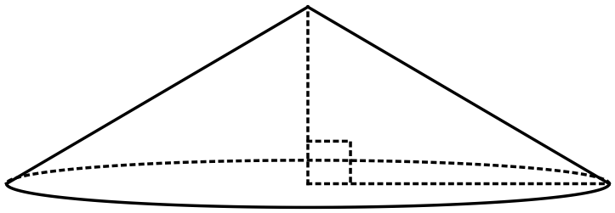

(a) Building regulations require that one air vent is required for every $30 {\text{m}}^{3}$ of space (or part) in the roof. Determine the number of air vents required for the roof shown. (3 marks)

(b) The curved surface of the roof is to be tiled (excluding the circular base). The tile that the builder has chosen has a coverage rate of $16$ tiles per square metre and can be bought in packs of $124$. Determine the number of packs the builder must order. (5 marks)

Question 16 (11 marks)

As part of an investigation into youth fitness, a researcher collected the sit-and-reach (SR) measurements of $250$ students. The data is summarised in the table below.

|  |  |
| --- | --- |
| SR measurement (cm) | Number of students |
| $$18<x≤22$$ | $$5$$ |
| $$22<x≤26$$ | $$10$$ |
| $$26<x≤30$$ | $$32$$ |
| $$30<x≤34$$ | $$68$$ |
| $$34<x≤38$$ | $$90$$ |
| $$38<x≤42$$ | $$36$$ |
| $$42<x≤46$$ | $$9$$ |

(a) Use the mid-point of each class interval to determine the mean and standard deviation of the sit-and-reach measurements. (2 marks)

(b) Explain why it was necessary to use the mid-point of each class interval to determine the statistics in (a). (1 mark)

(c) Draw a histogram on the axes below to display the distribution of SR measurements.

(3 marks)

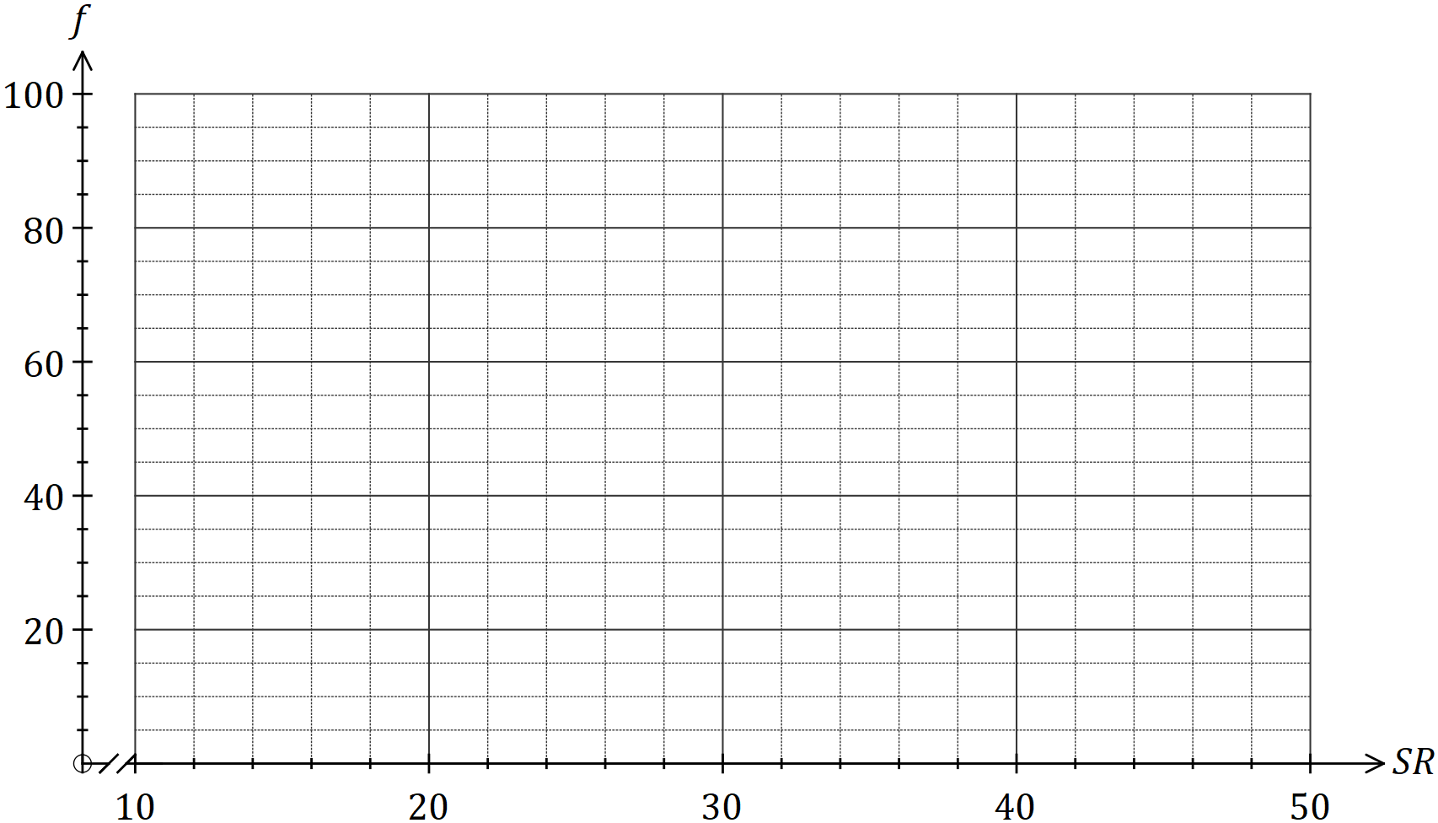

(d) Use features of the histogram to describe the distribution of SR measurements for this group of students. (3 marks)

(e) In a previous investigation, the researcher found that the SR measurements for an older group of people were normally distributed with a mean of $29 \text{cm}$ and a standard deviation of $3.4 \text{cm}$. Determine the percentage of people in this older group who had an SR measurement

(i) less than $25 \text{cm}$. (1 mark)

(ii) between $28$ and $38 \text{cm}$. (1 mark)

Question 17 (8 marks)

The top of a vertical pole $T$ stands $6.4 \text{m}$ above a surrounding level playing field. The angle of depression from $T$ to a small animal at $A$ is $32°$. The animal leaves $A$, moves directly towards the base of the pole $B$ and stops at $C$ (before reaching $B$). The distance $BC$ is $5.5 \text{m}$.

(a) Sketch a diagram to show the above information. (2 marks)

(b) Calculate the line of sight distance from the top of the pole to $A$. (2 marks)

(c) Determine the angle of depression from $T$ to $C$. (2 marks)

(d) Calculate the distance travelled by the animal from $A$ to $C$. (2 marks)

Question 18 (9 marks)

A second-hand car dealer paid $\$53 850$ for a vehicle and later sold it to a customer for $\$36 400$.

(a) Calculate the percentage loss incurred by the dealer. (2 marks)

(b) The customer paid a deposit of $\$4 400$ and took out a loan for the remainder of the price with an interest rate of $11.4\%$ per annum. Calculate the simple interest on the loan for the first month. (3 marks)

(c) The price the customer paid included $10\%$ GST. Calculate the amount of GST included in the price. (2 marks)

(d) The standard premium to insure the vehicle was $\$3 265$, but the customer was offered a discount of $65\%$ for not having made any claims over the past seven years. Determine the premium after the discount was applied. (2 marks)

Question 19 (7 marks)

A model of a triangular gable has measurements shown below, in centimetres.

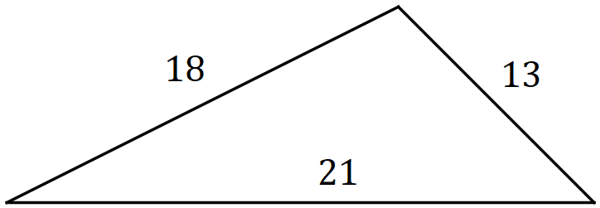

(a) Use Heron's rule to determine the area of the model of the gable. (3 marks)

The model was drawn to a scale using measurements taken from a building, where the length of the shortest side of the gable was $5.2 \text{m}$.

(b) Calculate the scale factor used to draw the model. (1 mark)

(c) The gable on the building requires repainting, at a cost of $\$21$ per square metre. Determine the cost of repainting the gable, to the nearest dollar. (3 marks)

Question 20 (7 marks)

The wind chill index $I$ is a measure of how quickly a person exposed to a wind will lose heat. It is calculated using the formula below, where $v$ is the speed of the wind in metres per second and $T$ is the air temperature in degrees Celsius.

$$I=\left(10\sqrt{v}-v+10.5\right)\left(33-T\right)$$

(a) Determine $I$ when the air temperature is $-2°C$ and there is a wind of $14 \text{m/s}$ blowing.

(2 marks)

(b) Calculate the change in the wind chill index when the air temperature is $-5°C$ and the strength of the wind increases from $6 \text{m/s}$ to $13 \text{m/s}$. (3 marks)

(c) A person is likely to suffer from frostbite when the wind chill index reaches $1 400$. At what temperature will this happen, on a day when the wind has a speed of $9 \text{m/s}$? (2 marks)

Question 21 (8 marks)

When working out the cost of building an in-ground swimming pool, a contractor calculates a shape factor $k$ to use in a spreadsheet, where

$$k=\frac{P^{2}}{5A} .$$

$P$ is the perimeter of the pool in metres and $A$ is the area of the pool in square metres.

Pool 1 is rectangular with a semi-circular end and pool 2 is rectangular with a cut-out as shown.

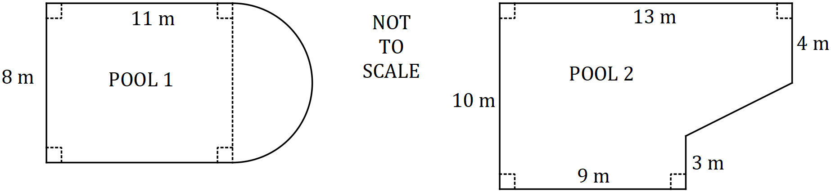

Determine, with justification, which of the pools shown has the larger shape factor $k$.

Supplementary page

Question number: _________

Supplementary page

Question number: _________

Supplementary page

Question number: _________